**What were the consequences of WW2 for Mandate Palestine?**

**Lesson 6**

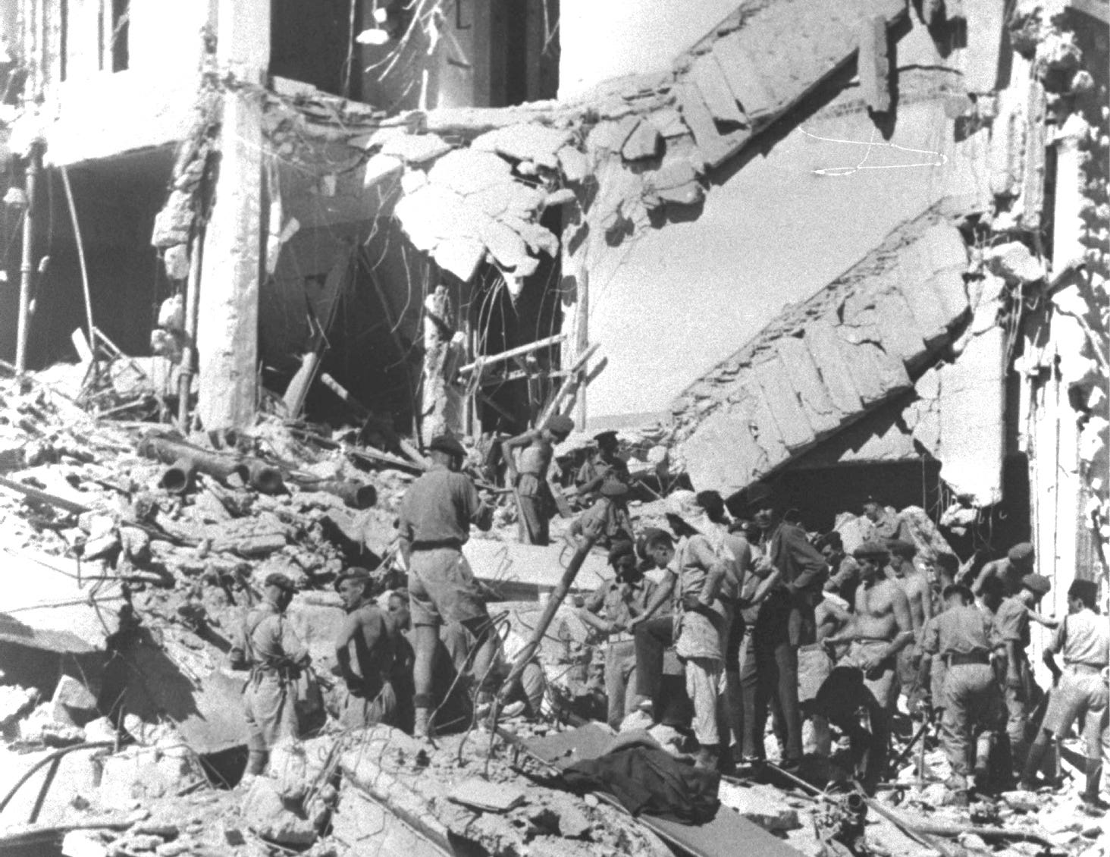

The King David Hotel bombing in July 1946

**By the end of this lesson, you should be able to:**

Describe the events of the late 1930s and early-mid 1940s in Mandate Palestine and Nazi Germany

Explain Britain’s wavering policies in Mandate Palestine at this time

Evaluate the effectiveness of British policy in Mandate Palestine during this period

**Keywords**

World War Two

United Nations

Oil

Holocaust

Concentration camp

**Knowledge check!**

1)What do you already know about World War Two?

2) What are the following statements referring to?

“The most disruptive Palestinian uprising during the British Mandate”

“By the end, 10% of Palestinian men had been killed, wounded or exiled”

**World War Two**

World War Two started when **Germany**, led by Adolf Hitler, invaded Poland, and in response to this, Britain and France declared war on Germany in **September 1939**. Other countries soon became involved, with the main **Axis powers** including Germany, Italy and Japan, and the main **Allied powers** including Britain, the USA, France and the Soviet Union (Russia).

This global war ended in Europe on 8May 1945 with Germany’s surrender. This is now known as Victory in Europe Day, or VE day. Shortly after this in early August, the USA dropped the **first atomic bombs** on the Japanese cities of Hiroshima and Nagasaki, and Japan then surrendered on **2 September 1945**. This is known as Victory over Japan Day or VJ Day.

World War Two was a **total war**, meaning that **all of society was involved**. In some countries, conscription meant that all eligible people must fight for their country, and innocent civilians became military targets. It is estimated that between **70 and 85 million people died** during the war.

World War Two brought many changes to the way the world works. Shortly afterwards, the **United Nations** was established to replace the failed League of Nations and prevent another war.

**Partition?**

In Lesson 5 we saw that there was increasing tensionbetween Palestinians and Jews in Mandate Palestine in the 1920s and 1930s, which often turned into violence. Key examples of this were the Nebi Musa riots in April 1920, the Jaffa riots in 1921 and the Western Wall riots of 1929. These tensions came to a head with the 1936-1939 Arab Revolt, a large-scale nationalist uprising of Palestinian Arabs against the British administration. At the start of the revolt, it was considered that Britain might need to **partition (split)** Mandate Palestine into one Palestinian state and one Jewish state. But Palestinians were not happy with this as it would result in a further loss of their land

**Activity**

Read through Britain’s concerns of 1939 below and answer these questions:

-Why were concerns A, B and C important to the British in 1939?

-Was one of these concerns more important than the others?

-What should Britain do now? Make sure to address what Britain should do about Jewish immigration in your answer

Concern B: War was looking increasingly likely now. Stability in Mandate Palestine and the Middle East more broadly was vital for the British because this area was home to important communication and supply lines, and oil! These things would be even more important than usual in the event of a war, so Britain needed stability in Mandate Palestine and the Middle East

Concern A: Britain needed to keep the Palestinians happy - it didn’t want a repeat of the Arab Revolt. The Arab Revolt had damaged buses, railways, oil pipelines and army posts in Mandate Palestine. The British had to deploy 20,000 soldiers to restore order (and unfortunately there were many incidents of brutality by British police and troops)

Concern C: Britain had promised to help with the establishment of a homeland for the Jews in Mandate Palestine. This promise had even been incorporated into the Mandate! This was now more important than ever, particularly in light of the way Jews were being treated in Nazi Germany

**The White Paper of 1939**

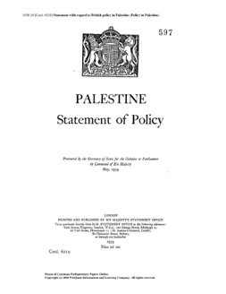

In May 1939, a decision was finally reached and published by Neville Chamberlain (British Prime Minister) in the White Paper of 1939. Here are the key points:

-Jewish immigration: restricted to 75,000 over 5 years

-Land purchase: Zionists could only buy Palestinian land in 5% of the country

-The future of Palestine-Israel: a Jewish national home would be established within an independent Palestinian state within 10 years

**Questions**

-What were the new limits on Jewish immigration to Mandate Palestine? How would this make you feel if you were Jewish?

-What were the limits to Zionist land purchase? How would this make you feel if you were Palestinian?

**Reactions to the 1939 White Paper**

The Palestinian leadership officially rejected the White Paper, whilst more moderate Palestinians were prepared to accept it

Zionist groups immediately rejected it and launched a campaign against it, but they recognised the need to work with the British when war broke out in September 1939:

*"We will fight the White Paper as if there is no war, and fight the war as if there is no White Paper”*

David Ben-Gurion, head of the Jewish Agency in 1939

**Activity**

Can you fill in the blanks using the words provided?

**The Holocaust**

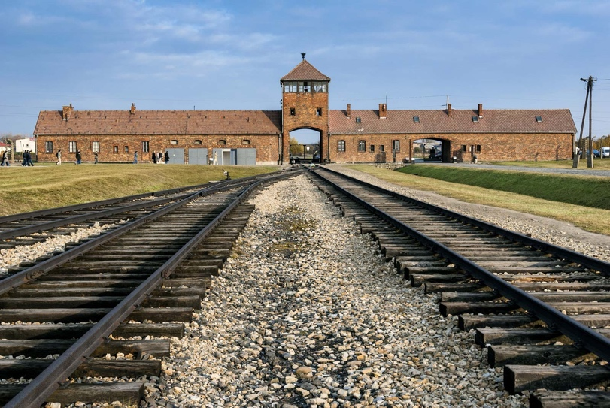

Auschwitz-Birkenau, one of the main concentration camps. Others included Belzec, Chelmno, Majdanek, Sobibor and Treblinka

Also known as the Shoah, the Holocaust was the **genocide** of 6 million European Jews between 1941 and 1945. It involved pogroms, mass shootings and the murder of Jews through forced labour and gas chambers. The Nazis called the extermination of Jews the “Final Solution” to the “Jewish Question”. By the end of the Holocaust, **two thirds of Europe’s Jewish population had been killed**

**The persecution of Jews in Germany**

Devastation from *Kristallnacht,* the “Night of Broken Glass”

The Holocaust is dated as 1941-1945, but the persecution of Jews in Germany began in the **early 1930s**. In 1933, concentration camps started to be built and Jewish businesses were boycotted. In 1935, the Nuremberg Laws were passed. These were **antisemitic laws** which deprived Jews of German citizenship and forbade marriage between Jews and “German citizens”. Then, on 9th and 10th November 1938, Jewish businesses and other buildings were attacked and set on fire throughout Germany and Austria. This was known as ***Kristallnacht****,* the “Night of Broken Glass”

**Activity**

Building on your timeline of antisemitism in Europe from Lesson 2, create a brief timeline of the persecution of Jews in Germany from 1933 to 1945

**The Irgun and the Lehi**

Many Jews in Mandate Palestine and beyond felt that the limits imposed on Jewish movement to Mandate Palestine during this period were cruel. As a consequence of this, two extremist Jewish groups emerged: the **Irgun** and the **Lehi**. They began a series of **brutal attacks** in Mandate Palestine, targeting offices and police stations. On 6th November 1944, Lord Moyne, a British minister of state, was assassinated by the Lehi in Cairo. Then, on 22nd July 1946, the **King David Hotel** in Jerusalem was bombed by the Irgun. This hotel had been the headquarters of the British Mandate administration and the British army, and 28 Brits, 41 Palestinians and 17 Jews were killed

**Britain turns to the United Nations**

As the concentration camps were liberated and the full horrors of the Holocaust came to light, there were increasing calls for an independent Jewish state in Mandate Palestine. But what about the Palestinians? The Palestinians had lived on this land for centuries and they had never received their promised independent state either. Britain did not know what to do. As the violence in Mandate Palestine continued, Britain’s position became **impossible to sustain**. In February 1947, Britain asked the newly established **United Nations** for help

**Activity**

In small groups, reflecting on today’s lesson, create a spider diagram with all the reasons why Britain asked the UN for help in February 1947. Are any of these reasons linked?

**Check your knowledge!**   
  
What were the consequences of WW2 for the following:

-Jews in Germany

-The British in Mandate Palestine

-Jews in Mandate Palestine

-Palestinians in Mandate Palestine

**Extension activity**

Explain **three** consequences of World War Two for Mandate Palestine.

Include these terms in your answer:

-Oil

-Holocaust

-Irgun